PMP Final Project

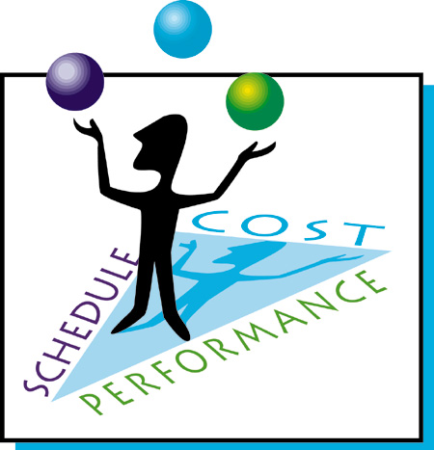

By: Alex Girard and Spencer Markin

Prof: Basil Burgess

Date: August 7th, 2013

Class: INFO20172

# Check list and title page:

* ~~Appropriate cover page~~
* ~~Completed Check list page~~
* ~~Project Charter (Task 1)~~
* ~~Scope Statement (Task 2)~~
* ~~WBS – List Form (Task 3)~~
* ~~Gantt chart (Task 4)~~
* ~~SMART paper (Task 5)~~
* ~~Milestone Report (Task 6)~~
* ~~Calendar (Task 6)~~
* ~~Gantt chart (Task 7)~~
* ~~Cost estimate (Task 10 version)~~
* ~~Report elements sequenced as required.~~

Term Assignment: INFO20172 Project Management for Information Technology

For Professor Basil Burgess

August 7th, 2013

Class: 93419

Team Members:

* Alex Girard
* Spencer Markin

# Project Charter(1)

**Project Title**: Idra, The Last Bonjwa

**Project Start Date:** September 1st, 2012 **Projected Finish Date:** July 1st,2013

**Budget Information:** $5000 grant to be primarily spent on hardware and software for the movie as well as food and any unforeseen costs during production.

**Project Manager:**

* Spencer Markin, 905-464-4064, markins@gmail.com
* Alex Girard, 905-464-8484, girardprogramming@gmail.com

**Project Objectives:**

* Create a video short to develop new skills that can be applied on the job.
* Submit video into contest before deadline

**Main Project Success Criteria:** Creating a finished product in order to gain valuable knowledge to help find a job after graduation.

**Approach:**

1. Determine technical requirements for creating an animated video.
2. Brainstorm to create an engaging and entertaining story for the video
3. Based off the story create the character which will be involved in the video
4. Create a storyboard for the animators to follow throughout the project
5. Record necessary audio for the project excluding voiceover work
6. Develop animations based off storyboard
7. Record voiceover for every character during each scene
8. Begin editing the film as well as mixing audio
9. Review film drafts
10. Make final changes
11. Copying the final project to film
12. Submit Project

# Project Charter (Con’t)

**Roles and Responsibilities**

|  |  |  |  |
| --- | --- | --- | --- |
| **Role** | **Name** | **Organization/**  **Position** | **Contact Information** |
| Project Manager | Spencer and Alex | Comp Sci Student | 905 464 4064 |
| Technical Producer | Alex | Comp Sci Student | 905 464 9565 |
| Script Writer | Dana | Uni. Theater Group | 905 464 4697 |
| Story Producer | Carlos | Uni. Theater Group | 905 464 8744 |
| Artwork | Sophie | Uni. Theater Group | 905 464 9832 |
| Voice Actor | Jake | Uni. Theater Group | 905 464 9832 |
| Music Producer | Scott | Music Dept. | 905 464 8977 |
| Film Promotion | Caroline | Marketing Major | 905 464 6587 |

**Sign-off:** (Signatures of all above stakeholders. Can sign by their names in table above.)

**Comments:** (Handwritten or typed comments from above stakeholders, if applicable)

I really want to test my computer and project management skills outside of my comfort zone, hopefully this will help me learn new skills in those respective fields. My main goal here isn’t necessarily winning the film festival; this is an experience I want to gain knowledge from – (Technical Producer) Alex

# Project Scope(2)

**Project Title:** Idra, The Last Bonjwa

**Date:** September 2nd, 2012

**Prepared By:**

* Spencer Markin, Co-Project Manager, Markins@gmail.com
* Alex Girard, Co-Project Manager, alexgirard@gmail.com

**Project Summary and Justification:** Alex, a senior computer science major is entering into a film competition hosted by an independent film production company. They require the film to be 2-5 minutes in length and can be of the traditional fashion with real actors and a script, or it can be done digitally were the actors are only allowed to do voiceovers and all the visuals must be computer generated. Alex being a computer science major felt his skills would be better suited for the digital video. The competition allows allots 10 months to complete the project and the prizes are $100,000 and a chance to participate in a major film contest, $50,000, $25,000 for first, second and third place respectively. Alex was granted $5,000 from his university that he can use to purchase any specialized software or hardware that the university could also use. He is also allowed to give up to $500 stipends for volunteers who contributed to the project. Although Alex strives to win the competition, his main goal is to acquire valuable skills and experiences that will help him pursue his future career endeavors.

**Project Characteristics and Requirements:**

* **Film Topic:** Should be something that could run as a film preview
* **Video Time Frame:** The film must be between 2-5 minutes
* **Video Animation:** All video animations must be produced digitally using a computer
* **Film Promotion:** Should be available as film preview, distributed on internet and available on wireless devices such as smart phones.
* **Target Audience:** Should be appropriate for an audiences under 17 years old

**Summary of Project Deliverables**

* **Project Management Related Deliverables:** Project Charter, Scope Statement, WBS List Form, Gnatt Chart, SMART paper, Milestone Report, Calendar, Gnatt Chart, Cost estimate, PPTX version of power point presentation, Lessons learned document, and any other documents requited to manage to project.
* **Product Related Deliverables:**
* **Technical Requirements:** Have technical producer (Alex) obtain and set up the software and hardware to cost effectively complete to project while meeting requirements.
* **Story Concept:** All members of the team will be asked to brainstorm ideas for the plot which will be reviewed by the Story Producer (Carlos) to decide on a final direction for the Story.
* **Character Development:** Script Writer (Dana) will work with the voice actor (Jake) and Animator (Sophie) to create and develop the characters of the story.

# Project Scope(Con’t)

* **Storyboard:** Animator Sophie will work with Script Writer (Dana) as well as Story Producer (Carlos) to create stills of each scene to develop a story board to for the team to refer too.
* **Animations:** Technical Producer (Alex) will set up required software and hardware for Animator (Sophie) to produce the project’s animations. He will also color Sophie’s animation frames.
* **Audio Production:** Technical producer (Alex) will work with Music Producer (Scott) to record the background music and sound effects for the project.
* **Record Voiceovers:** Technical Producer (Alex) as well as Music Producer (Scott) will record Voiceovers for the animations. The Voiceovers will be provided by Actor (Jake) under the supervision of Script Writer (Dana) and Story Producer (Carlos) to ensure character’s match their vision of the character’s in the story.
* **Film editing:** Technical producer (Alex) will use software to edit and create the film with animator’s (Sophie) animations.
* **Audio Mixing:** Music producer (Scott) will work with Technical Producer (Alex) to sync characters voiceovers with animations, add required sound effects and background music, and adjust audios levels throughout the film.
* **Preliminary Draft:** Have a private screening of the draft with the project’s team. Ask for feedback on the draft. Bring any concerns to Story Producer (Carlos) who will work with Technical Producer (Alex) and Music Producer (Scott) to complete any editing touchups that need to be implemented. This step may go through multiple iterations.
* **Final Edit:** Technical Producer (Alex), Music Producer (Scott) and Story producer (Carlos) will produce a final edit which will be copied on to film.
* **Film Promotion:** Film Promoter (Caroline) will work with Animator (Sophie) to create posters for the project to be displayed at the film festival. Film Promoter (Caroline) will also draw interest to the film through various social media sites such as: facebook, twitter, and youtube.

**Project Success Criteria:** Our goal is to produce a video short within 10 months that is compliant with film festival rules while not exceeding our budget of 5000 dollars. The project’s technical producer (Alex) has stated that his main goal is acquiring knowledge and skills that will help him in a real life work scenario. Winning the film festival is something the project team will strive for, however is not required to determine the success of the project.

# Work Breakdown Structure (3)

1. **Initiating**
   1. Assemble team
   2. Prepare project charter
   3. Prepare team contract
2. **Planning**
   1. Organize team planning meeting
   2. Create scope statement
   3. Create preliminary WBS
   4. Create preliminary Gnatt Chart
   5. **Prepare Schedule**
      1. Determine required deadlines
      2. Estimate task durations
      3. Update WBS with time constraints
      4. Create and review Gnatt Chart
3. **Pre-Production**
   1. Brainstorm story concept
   2. Finalize story concept
   3. Character development
   4. Develop Storyboard
   5. Write script
4. **Production**
   1. Produce animations
   2. Record sound effects and music
   3. Record voiceovers
5. **Post-Production**
   1. Begin preliminary film editing
   2. Sync voiceovers
   3. Add sound effects and music
   4. Review drafts for any changes
   5. Edit final Draft with changes
6. **Distribution** 
   1. Promote film
   2. Submit to film festival

# Preliminary Gnatt Chart(4)

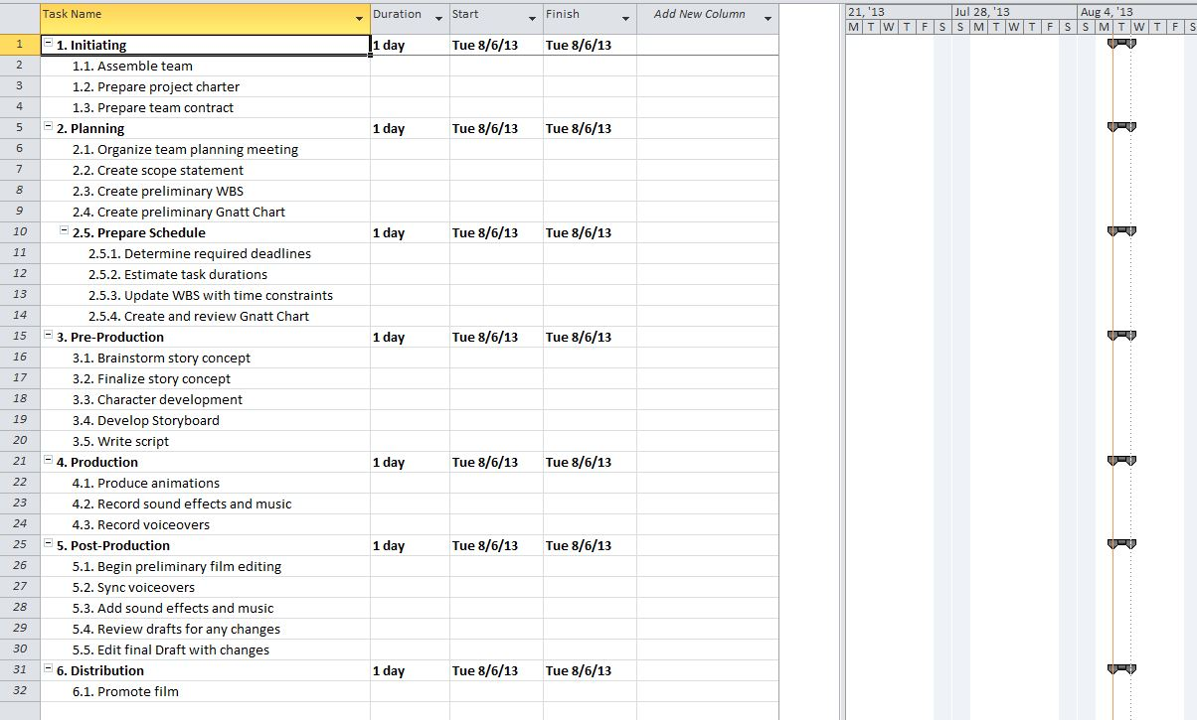

# Smart Paper (5a)

**Team Assembled:** Spencer will have the team assembled on September 21st, 2012. Team must have a diverse skill set and be built off of former project partners or recommendations from former project partners. Spencer plans to have 5, 1 hour interviews per week.

**Initiating Phase Completed:** Spencer will have the Project Charter, and Team Contract all filled out and completed as well as the Team assembled on September 24th, 2012. He estimates assembling the Team will take a total of 3 weeks, while creating the Project Charter and Team contract will take a total of 1 day totaling 2 hours.

**Preliminary Documents Created:** Spencer will have the Scope Statement, Preliminary WBS, and Preliminary Gnatt Chart completed by October 5th, 2012 estimating a total of 8 hours to complete all 3 documents and plan the project team meeting (2 hours each).

**Planning Phase Completed:** The Planning Phase will be completed by Spencer the day before the exam week on October 19th, 2012. He estimates it will take a total of 10 hours to complete scheduling as well as update the Working Breakdown Structure and Gnatt Chart.

**Pre-Production Completed:** Following the exam week the team will resume the project in the pre-production phase which will begin on October 29th, 2012. For the first 2 days the team will have 1 hour brain storming sessions to come up with ideas for the story totaling 2 hours each. Carlos will take the remaining 3 days of the week to finalize the film’s story estimating the total time of 9 hours. Starting on November 5th, 2012 Dana, Jake, and Sophie will begin developing the characters, expecting them to be fully developed by November 8th, 2012 totaling 17 hours. After the completion of the Character development Carlos, Sophie and Dana will then finalize the storyboard starting on November 12th, 2012 and finishing by November 23rd, 2012 totaling 30 hours. The Pre-Production phase will end on November 30th, 2012 after the script is finalized.

**Animations Completed:** Starting December 3nd, Sophie will begin drawing the 1200-3000(length in seconds multiplied by 10 frames per second) required frames for the Film. Alex will work alongside Sophie using software to color a frame after she completes it. Spencer estimates this will be the most Time consuming part of the project, and is allocating 2 and a half months to complete the animation frames. This task will be completed on February 15th, 2013. Both Alex and Sophie will be 18 hours per week during this entire task.

**Audio Recording Completed:** The audio tasks are scheduled to be completed within 20 hours between February 18th, 2013 and February 22nd, 2013. During the first 16 hours Alex and Scott will work on creating and recording the audio and sound effects. Alex will then work with Jake on February 22nd, 2013 to complete the voiceovers for the characters in the video short.

**Preliminary Draft Completed:**  After all the animations are drawn and the audio is recorded, Alex will begin to edit the Preliminary Draft. This Task is started on February 25th, 2013 with help from Scott to balance the audio levels as well as sync voiceovers. Spencer has estimated that Alex will complete the preliminary draft by February 28th, 2013 at a total of 20 hours.

**Review Preliminary Draft:** The team will assemble on March 1st, 2013 to review the preliminary draft. The actual view time may only equate to 15 minutes, however Spencer believes it is a good idea to follow it with a 45 minute discussion on how they could improve the film.

**Review Final Cut:** After 2 months of reviewing drafts and making changed the team will assemble one last time to view the Final Product. This final screening before entering the distributing phase will be held on May 1st, 2013.

**View Film Festival Screening:** Team will attend Film Festival to show off the final cut.

# Milestone Report (5b)

|  |  |  |  |  |
| --- | --- | --- | --- | --- |
| **Milestone** | **Date** | **Status** | **Responsible** | **Issues/Comments** |
| **Initiating**  Team Assembled | September 21st, 2012 |  | Spencer |  |
| Initiating phase Complete | September 24th, 2012 |  | Spencer |  |
| **Planning**  Preliminary Documents Created | October 5th, 2012 |  | Spencer |  |
| Planning Phase Completed | October 19th, 2012 |  | Spencer |  |
| **Pre-Production**  Pre-Production Completed | December 1st, 2012 |  | Carlos, Dana |  |
| **Production**  Animations Completed | February 15th, 2013 |  | Sophie, Alex |  |
| Audio Recording Completed | February 22nd, 2013 |  | Alex, Scott, Jake |  |
| **Post-Production**  Preliminary Draft Completed | February 28th, 2013 |  | Alex, Scott |  |
| Review Preliminary Draft | March 1st,2013 |  | Whole Team |  |
| Review Final Cut | May 1st, 2013 |  | Whole Team |  |
| **Distribution**  Submit Final Cut | July 1st, 2013 |  | Alex |  |

# Calendar (6)

# 

# Finalized Gnatt Chart (7)

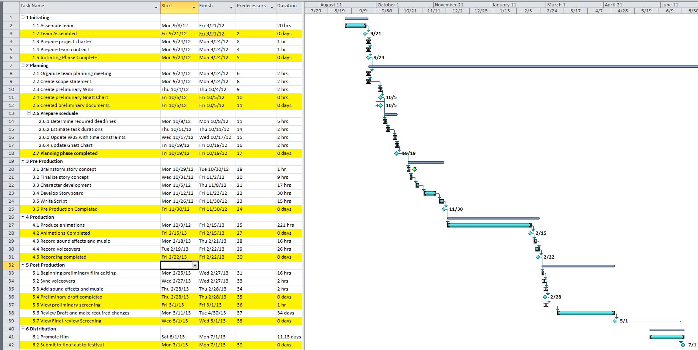

# Time Spent on Each Task(8)

|  |  |  |  |  |  |  |  |  |
| --- | --- | --- | --- | --- | --- | --- | --- | --- |
|  | **Spencer** | **Alex** | **Carlos** | **Dana** | **Sophie** | **Scott** | **Jake** | **Caroline** |
| **Assemble Team** | 15 |  |  |  |  |  |  |  |
| **Create Project Charter** | 1 |  |  |  |  |  |  |  |
| **Create Team Contract** | 1 |  |  |  |  |  |  |  |
| **Organize Planning Meeting** | 2 |  |  |  |  |  |  |  |
| **Create Scope Statement** | 2 |  |  |  |  |  |  |  |
| **Create Preliminary WBS** | 2 |  |  |  |  |  |  |  |
| **Create Preliminary Gnatt Chart** | 2 |  |  |  |  |  |  |  |
| **Determine Required Deadlines** | 2 |  |  |  |  |  |  |  |
| **Estimate Task Durations** | 2 |  |  |  |  |  |  |  |
| **Update WBS with Time Constraints** | 2 |  |  |  |  |  |  |  |
| **Update Gnatt Chart** | 2 |  |  |  |  |  |  |  |
| **Brainstorm Story Concept** | 1 | 1 | 1 | 1 | 1 | 1 | 1 | 1 |
| **Finalize Story Concept** |  |  | 9 |  |  |  |  |  |
| **Character Development** |  |  |  | 17 | 17 |  | 17 |  |
| **Develop Storyboard** |  |  | 30 | 30 | 30 |  |  |  |
| **Write Script** |  |  | 15 | 15 |  |  |  |  |
| **Produce Animation** |  | 221 |  |  | 221 |  |  |  |
| **Record Sound Effects and Music** |  | 16 |  |  |  | 16 |  |  |
| **Record Voiceovers** |  | 4 |  |  |  |  | 4 |  |
| **Beginning Preliminary Film Editing** |  | 16 | 16 |  |  |  |  |  |
| **Sync Voiceovers** |  | 2 | 2 |  |  | 2 |  |  |
| **Add sound effects and music** |  | 2 | 2 |  |  | 2 |  |  |
| **Review Draft and make Changes\*** | N/A | N/A | N/A | N/A | N/A | N/A | N/A | N/A |
| **Promote Film** |  | 264 |  |  | 50 |  |  | 264 |
| **Submit Film to Festival** |  | 1 |  |  |  |  |  |  |
| **TOTAL HOURS** | **34** | **526** | **75** | **62** | **319** | **21** | **22** | **265** |

NOTE * Depends on what changes need to be made to the film

# Cost Estimate (9, 10)

